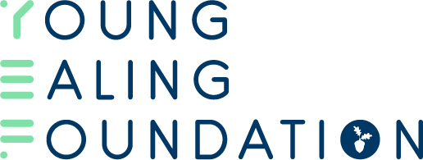
SMALL GRANTS GUIDANCE
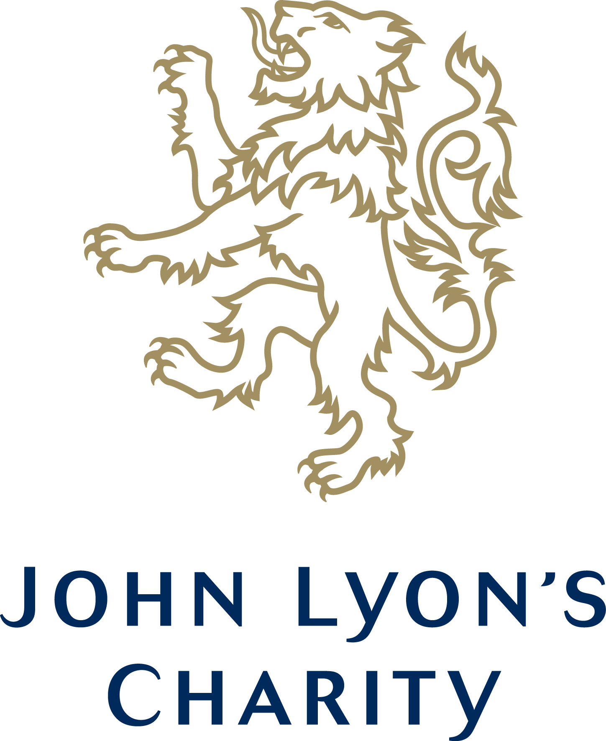
About the fund:
John Lyon’s Charity has provided the Young Ealing Foundation £100,000 to distribute as small grants to children and young people’s organisations in Ealing. The core purpose of the fund is to support groups that cannot access funding directly from larger funders, such as John Lyon’s Charity. The small grants will provide funding at a micro-level where it is most needed, helping small groups to grow and develop following the COVID-19 pandemic.

Eligibility Criteria:
To be eligible to apply your organisation must meet the following criteria:
- A Young Ealing Foundation member.
- Have an annual income under £250,000.
- You have two unrelated signatories.
- Have a Constitution.
Please note if you are not a Young Ealing Foundation Member, you can sign up and apply at the same time.
Available Funding
Eligible organisations can apply for grants up to £5,000 for either;
- Projects working with children and young people
OR
- Core costs – if your organisation exclusively supports children and young people.
Key Priorities for the Fund
As outlined in the objective for the fund, this fund seeks to support those ineligible for funding from larger funders. As such, those who have not been in receipt of John Lyon’s Charity funding will be prioritised. In addition, the Young Ealing Foundation will be prioritising projects which align with the following themes:
- Digital Exclusion
- Attainment Gap
- Youth Crime & Safety
- Employability
- Mental Health
- Domestic Abuse & Hate Crime
How to Apply:
You must complete the Small Grants Application form which is available from our website – www.youngealingfoundation.org.uk/grants. In addition, you must also complete the budget template provided.
Top Tips for a Good Application Form:
Eligible applications will be put to two separate panels, one of young people and the other of local sector leaders. With this in mind, when completing your application form please remember these tips:
- Describe the work you do, its importance and the people you support in a way which is clear and understandable. Avoid using jargon and let your passion for your work shine through.
- Tell us the operational aspects of your project. The panel will want to know how many young people, how many sessions and how you will deliver the project and with what staff.
- Ask for what you need – make sure you are asking for an appropriate amount of money for the size/scale of the work you are doing.
- Use your young people! Youth voice in an application adds depth and essential perspective to any funding application.
- Be clear in your budget – make sure you elaborate on costs. For example include the salary and hours of any staff costs. Do not just put Youth Worker £X Amount.
Deadlines and Decisions:
Detailed below are the upcoming deadlines and decision dates for the fund. Please note being unsuccessful in a previous round does not prevent you from applying in subsequent rounds.
31st December | January Meeting
28th February | March Meeting

Talk to Us:
If you have any further questions about the fund or the application fund please feel free to get in touch on info@youngealingfoundation.org.uk

